Abstract for CLES (title with 14 pt, Bold)

Hiroshi AZECHI ¹, and Hiroyuki SHIRAGA ² (12pt)
1) Institute of Laser Engineering, Osaka University, Japan (12pt italic)
E-mail;email@your.institute.jp

The Conference on Laser Energy Science (CLES2016) [1] will be held jointly with Fourteenth International Workshop on Fast Ignition & High Field Physics with High Power Lasers [2] at Pacifico-Yokohama, Yokohama Japan, on May 17 (Tue) - 20 (Fir), 2016.
This workshop, held every two years, brings together the leading international researchers in the field of Fast Ignition Inertial Confinement Fusion and High Field Physics with High Power Lasers. This workshop will continue the series of successful workshops, the most recent of which were held in Boston (2006), Crete (2008), Shanghai (2010), Napa (2012), and Oxford (2014).

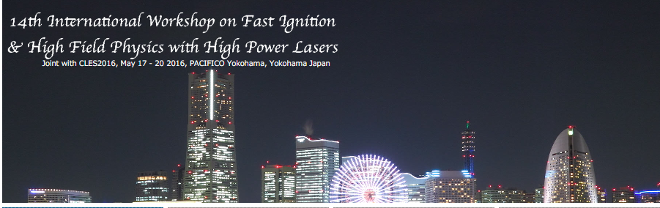
Figure 1: Night view of Yokohama bay area.

Abstract should be written in clear English on an A4 size paper (297×210 mm) with a 25 mm margin on all sides. The text should be typed in one column format with 12 pt font size. “Times New Roman” font or equivalent is recommended. The total length will be limited to ONE page for all presentations. Page number should not be added for easily making the abstract book. Please refer to the sample MS-WORD file for more details.
Abstract submission can be made via registration Web site. Please prepare a PDF file of your abstract which should involve all fonts and graphics used in the file. The authors are requested to check the computer file by themselves. Then, please submit the PDF file to the submission site (http://opicon.jp/submission/) no later than January 25, 2016. (Please make sure to select “CLES 2016” at the submission.)

References
[1] Web page of OPIC 2016 (http://opicon.jp).
[2] Web page of IWFI 2016 (http://www.ile.osaka-u.ac.jp/FIWS2016).

